Subject | Anti-Slavery and Human Trafficking Statement
Issued by | HR Department
Applies To | Xtratherm Ltd
Issued | December 2020

Xtratherm Group manufactures and distributes a range of innovative insulation solutions to meet building regulations, low & zero carbon building fabrics. As a business we employ over 300 people, we understand the importance of duty of care to our employees and the right to earn a living wage.

Xtratherm maintains relationships with many different organisations in its supply chain, as well as directly employing large numbers of people. Xtratherm has a zero-tolerance approach to modern slavery both within the Group and within its supply chain. We have reviewed our existing compliance and risk management processes following the introduction of the Modern Slavery Act 2015, to determine to what extent measures already exist, and what further measures may be required to prevent slavery and human trafficking taking place in any part of our businesses or in our supply chains. The policy below underpins our approach, and will be used to inform our annual Statement on Slavery and Human Trafficking.

Our Code of Conduct states that Xtratherm respects fundamental human rights and is committed to the principles set out in the United Nations Universal Declaration of Human Rights. We support and respect the protection of human rights within our sphere of influence; in particular the effective elimination of compulsory labour and child labour.

The Code of Conduct governs all our business dealings and the conduct of all persons or organisations with whom we contract directly or who we appoint to act on our behalf.

This Code of Conduct applies to all Xtratherm Group operations and employees. Xtratherm expects equivalent standards of conduct from all persons acting on its behalf, such as suppliers and partners.

We are committed to opposing modern slavery in all its forms and preventing it by whatever means we can. We demand the same attitude of all who work for us and expect it of all with whom we have business dealings. Our attitude to modern slavery is: zero tolerance.

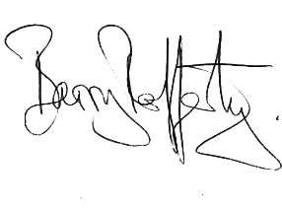

Barry Rafferty
Managing Director

